



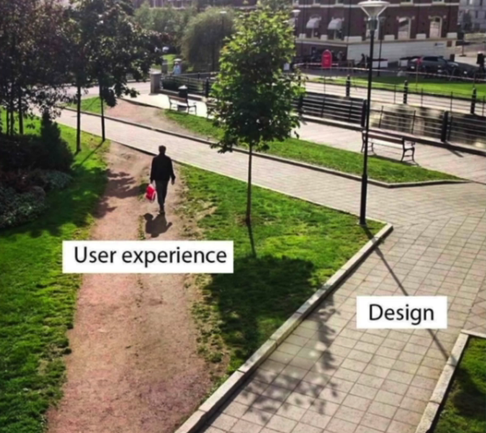

Malo

avoid

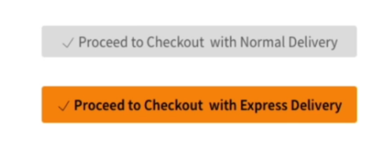

The hair

????????????